Kate Jaffe

May 6th, 2016

BI471 HW4

1. 7.1, 7.2, 7.4:

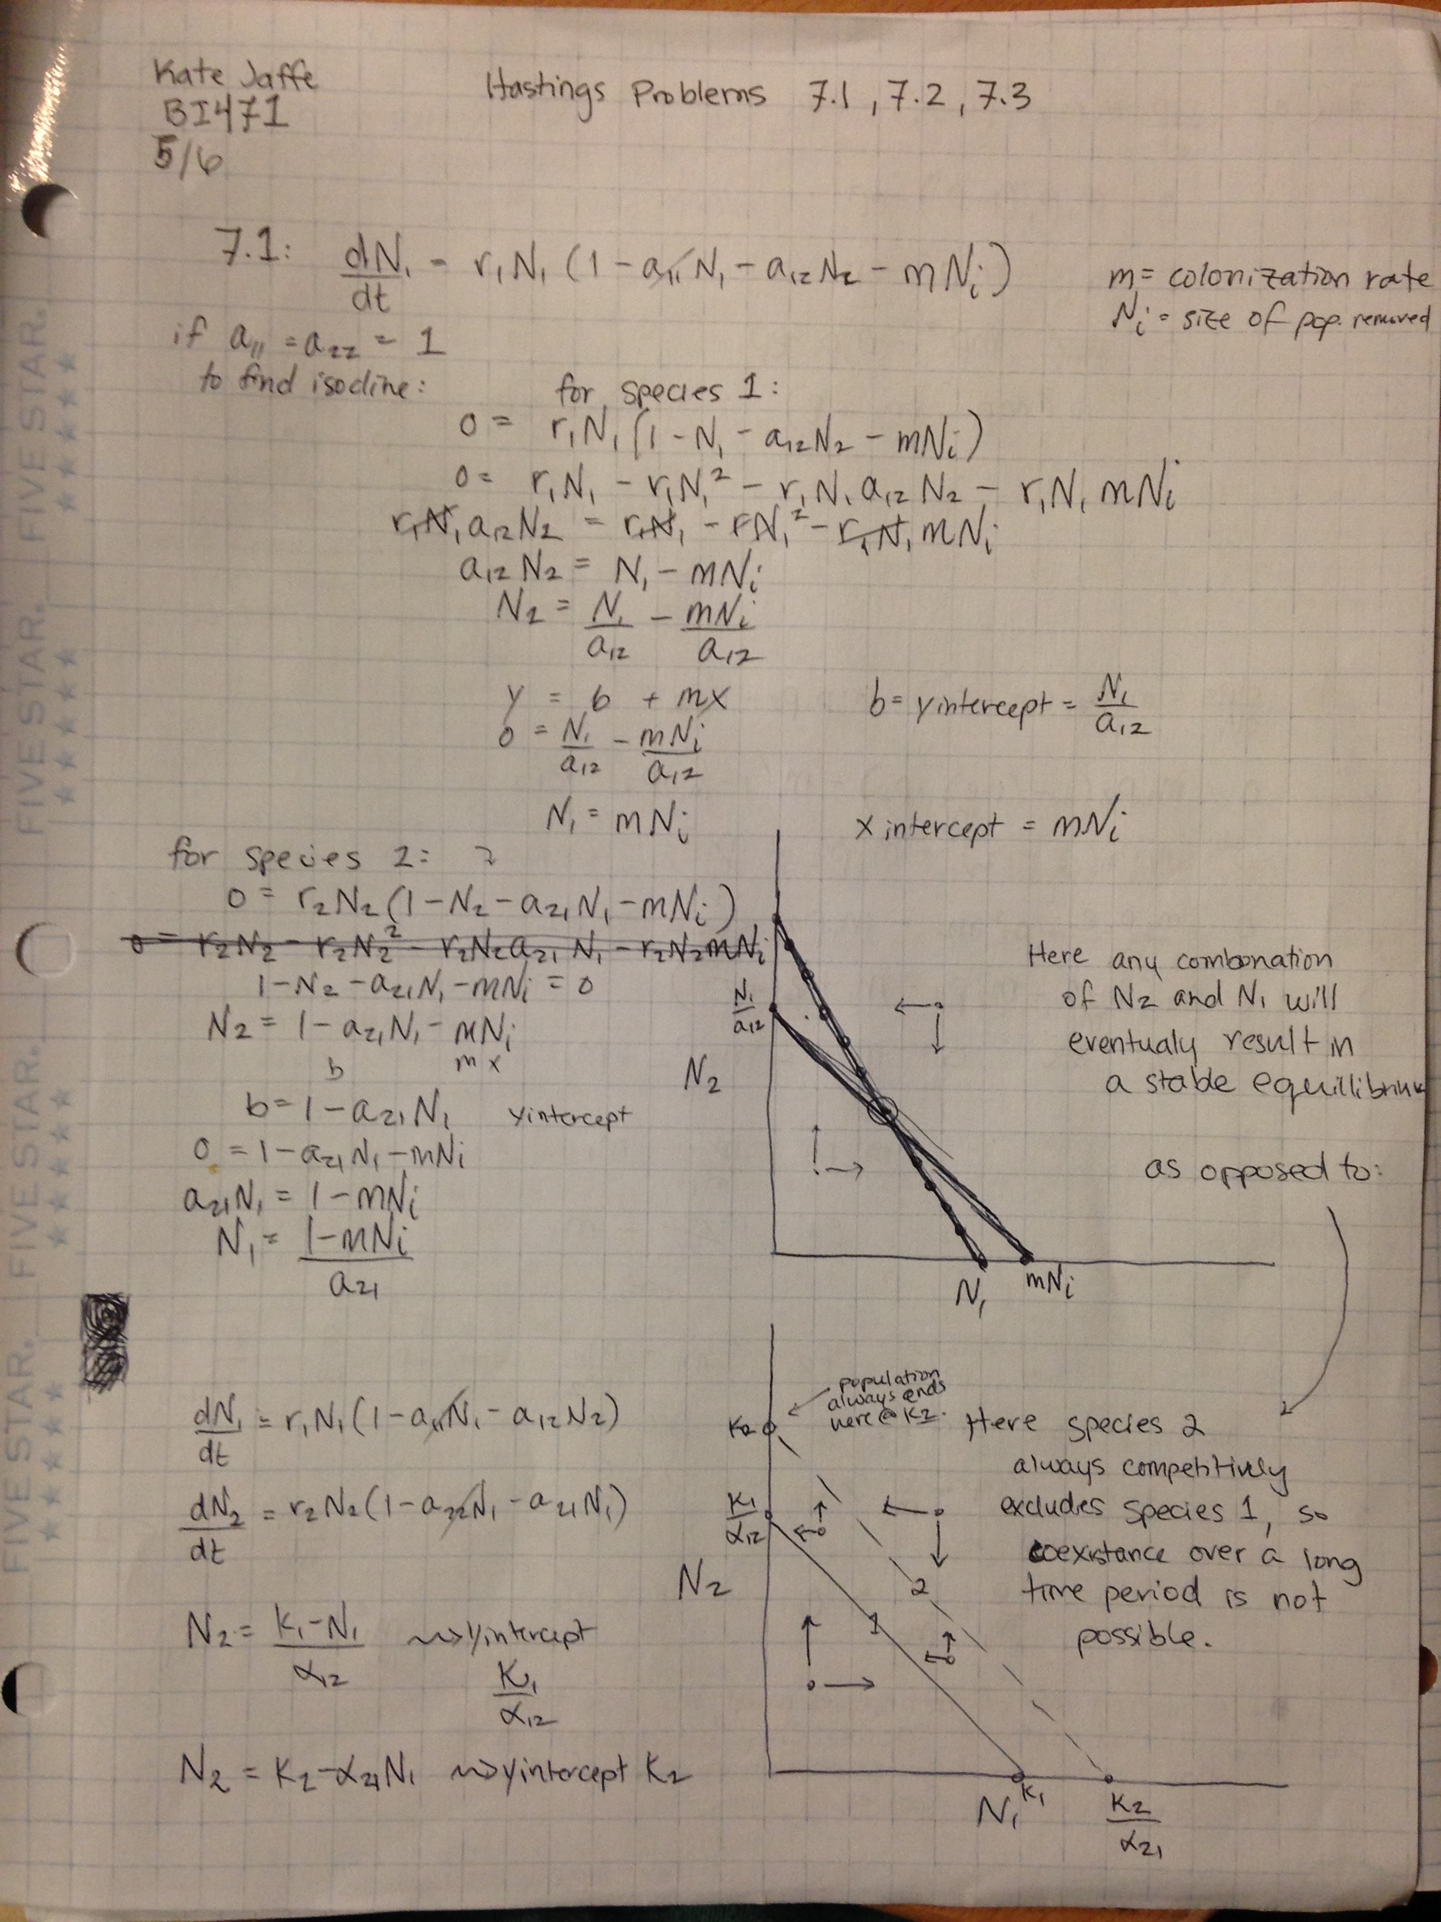

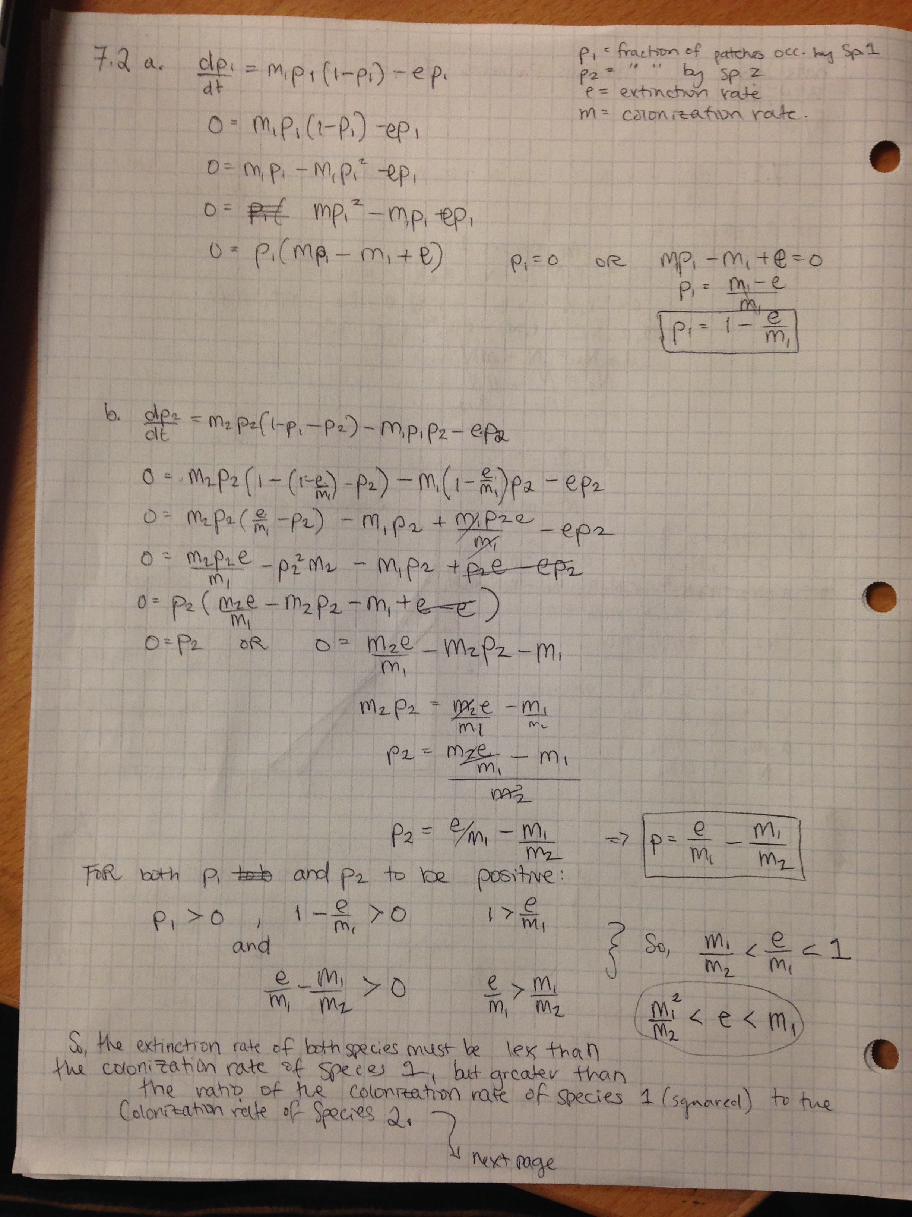

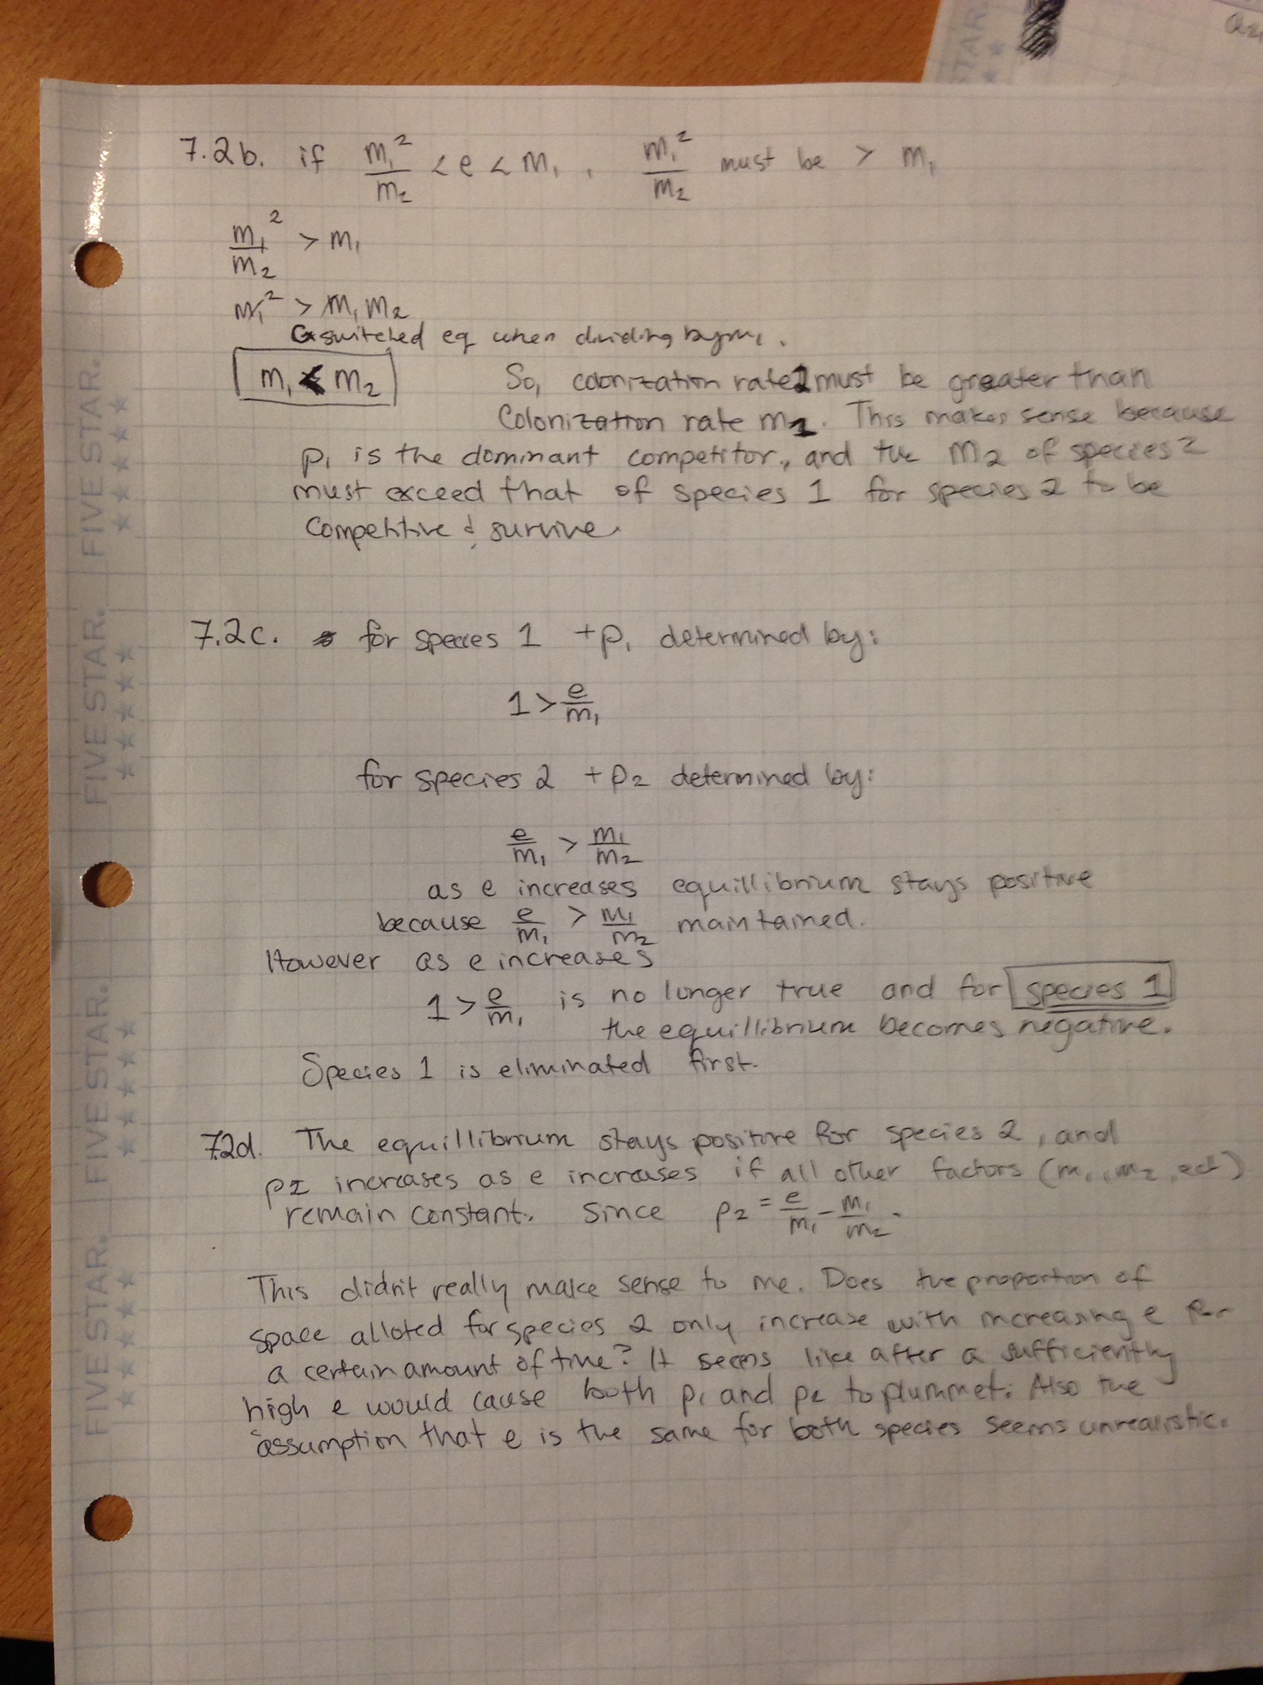

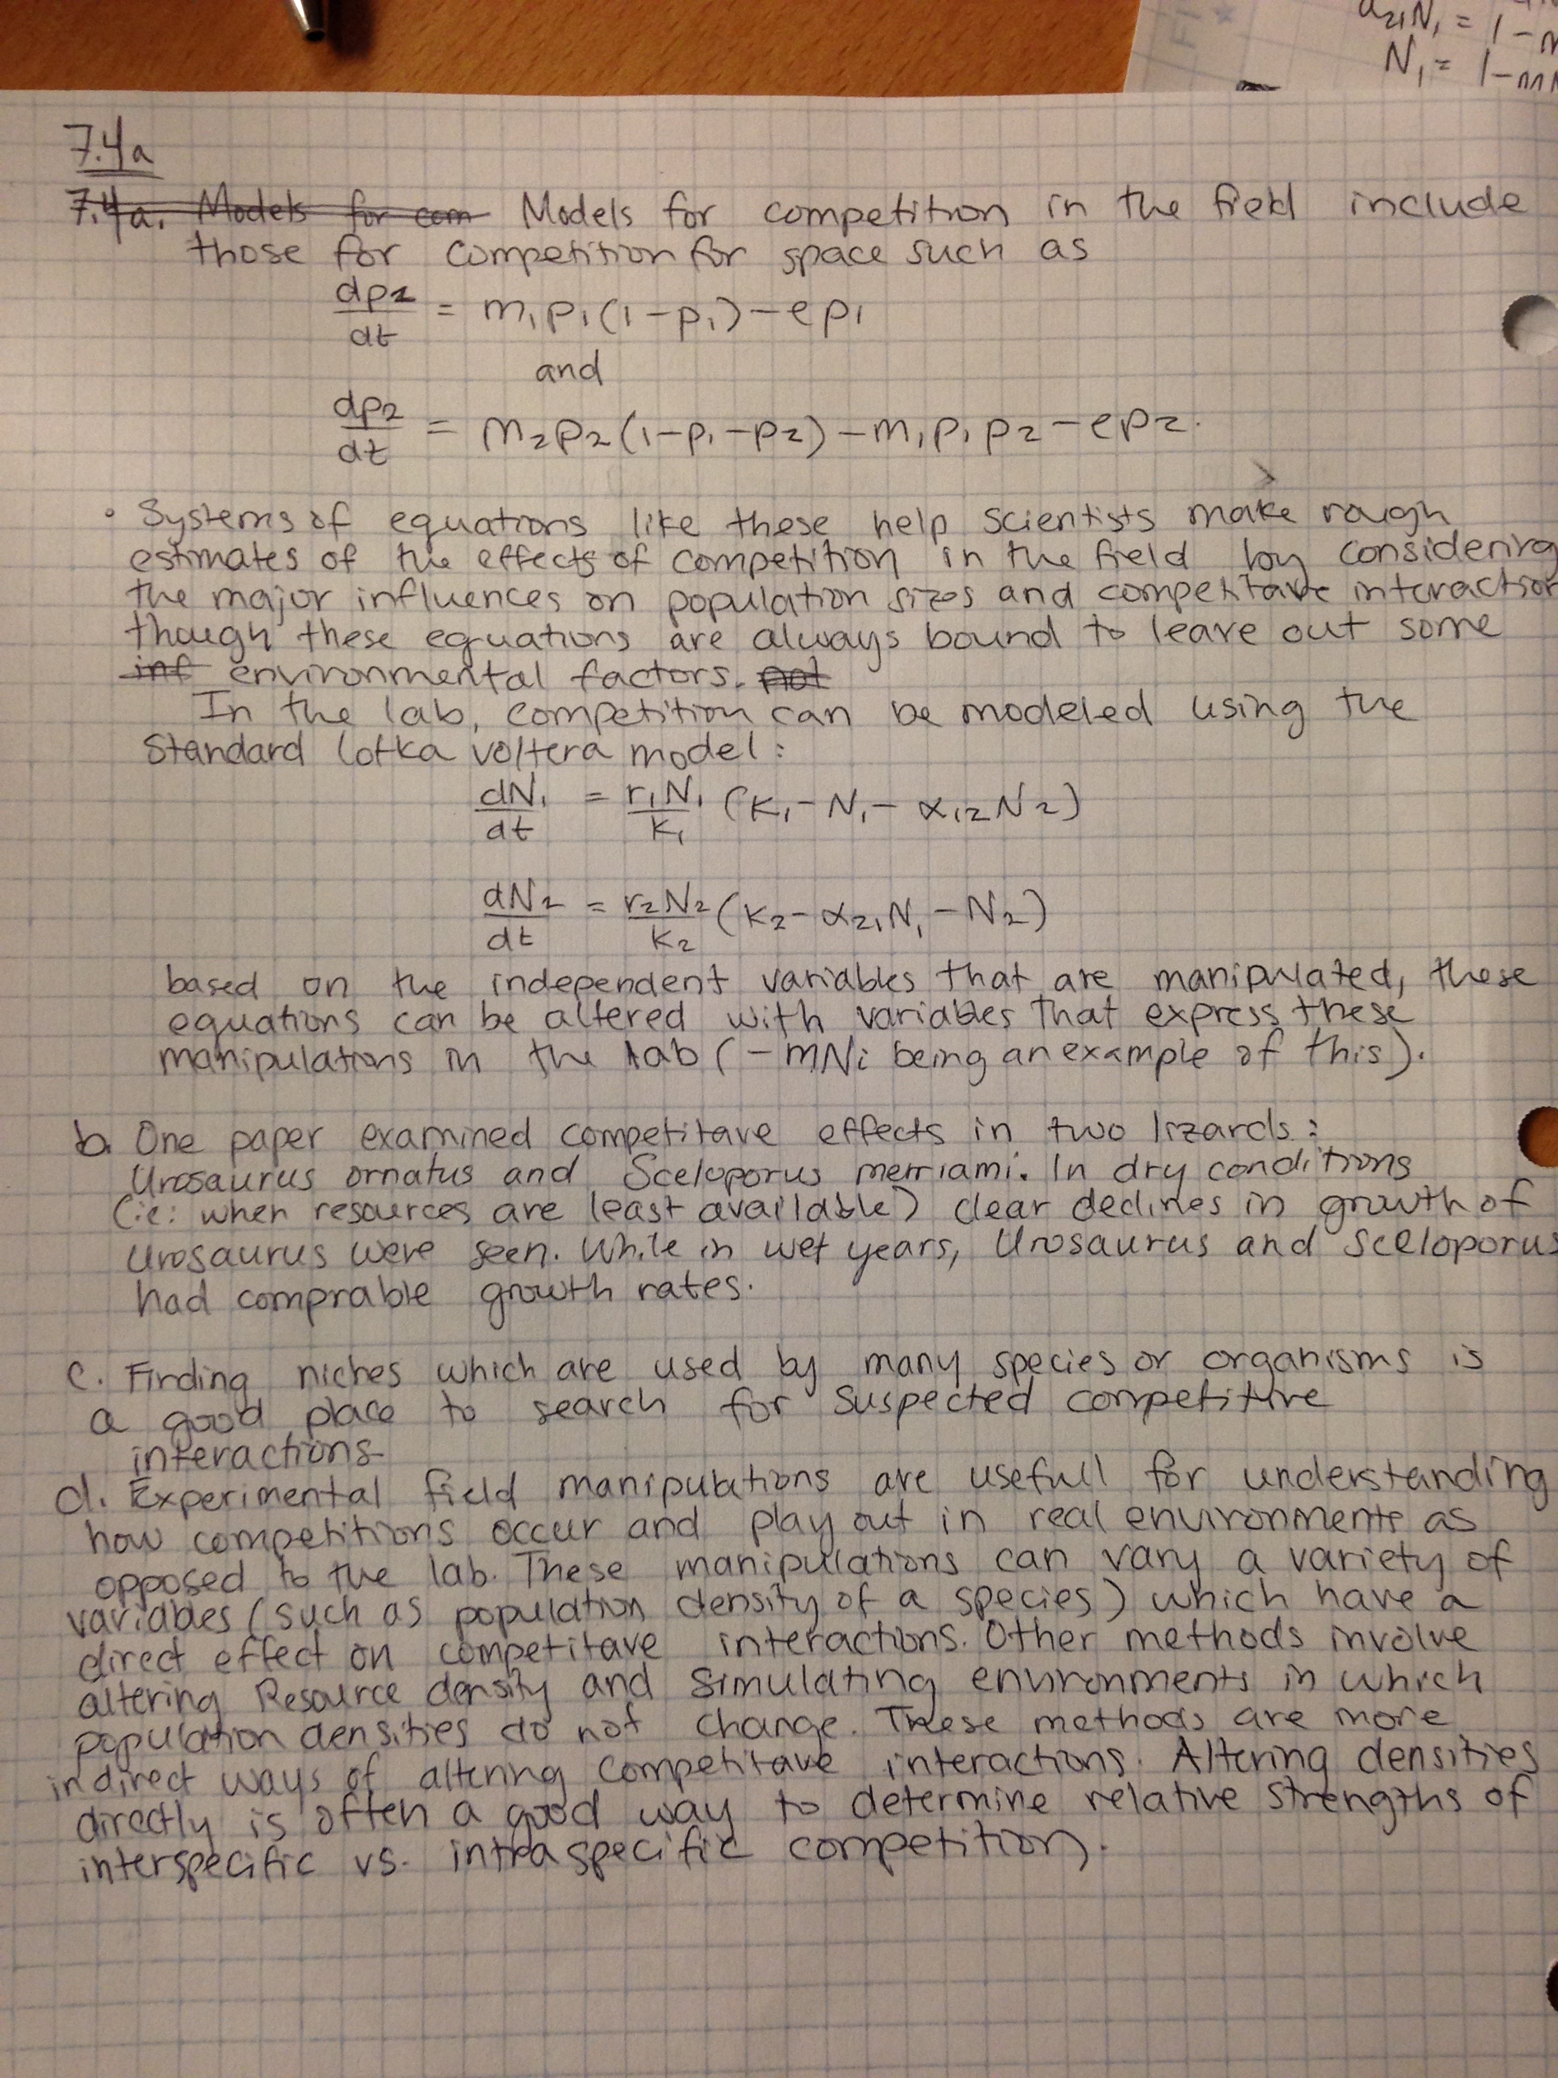

Citations for 7.4:

Connell, Joseph H.. “On the Prevalence and Relative Importance of Interspecific Competition: Evidence from Field Experiments”. *The American Naturalist* 122.5 (1983): 661–696. Web...

Schoener, Thomas W.. “Simple Models of Optimal Feeding-territory Size: A Reconciliation”. *The American Naturalist* 121.5 (1983): 608–629. Web.

2. R code:

library('deSolve')

# now we write competition function. add N2 and N1.

#re write equation to be equation for competition interactions.

comp <- function(t, y, p) {

N1 <- y[1]

N2 <- y[2]

with(as.list(p), {

dN1.dt <- (r1 * N1 / K1) * (K1 - N1 - a12 * N2)

dN2.dt <- (r2 * N2 / K2) * (K2 - N2 - a21 * N1)

return(list(c(dN1.dt, dN2.dt)))

})

}

t <- 1:20

y0 <- c('N1' = .1, 'N2' = .1)

p <- c('r1' = .1, 'r2' = .6,

'K1' = 2, 'K2' = 1,

'a12' = .15, 'a21' = .3)

sim <- ode(y = y0, times = t, func = comp, parms = p,

method = 'lsoda')

sim <- as.data.frame(sim)

plot(N1 ~time, type = 'l', col = 'blue', bty = 'l', data = sim, ylim = c(0,2))

points(N2 ~time, type = 'l', lty = 2, col = 'green', bty = 'l', data = sim)

Plot of population vs. time for 20-day study:

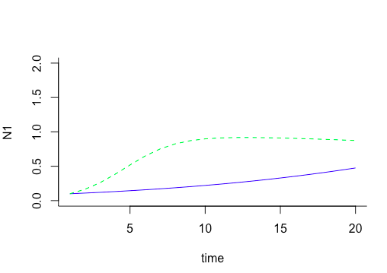

The conclusion from this 20 day experiment would be that species 2 (green line) has a greater carrying capacity than species 1 (blue line), and so will be the most competitive of the two species.

Plot of population vs. time for 100-day study:

(only parameter changed in code was t <- 1:20 to t <- 1:100)

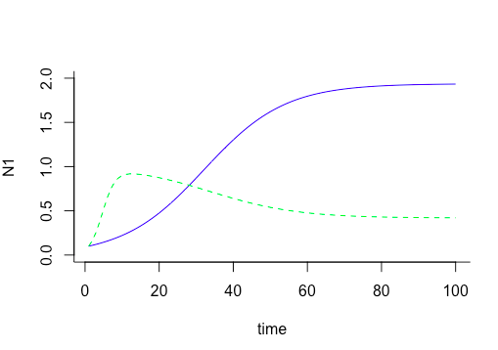

In this case, my conclusions would be quite different. The population of species 1 plateaus at a greater carrying capacity than species 2, and so is more competitive in the sense that it has a greater population at equilibrium. It does appear, at least from the available data, that there is a steady state after about 70 days, and that coexistence between these two populations is possible. This is an example of how short term studies may not be able to predict long-term effects, and how it may take two competing populations many cycles to reach a steady state, if they reach a steady state at all. In this way, the conclusions of a short-term study may be unreliable.